**PROJECT REPORT**

**Implementing CRM For Result Tracking Of A Candidate With Internal Marks - (DEV)**

1. **INTRODUCTION**

This is a result tracking system of Internal marks for candidates which is a sort of salesforce software meant to assist educational organisations in managing their students' performance. It automates the entire result management process. The software enables the handling of massive amounts of student data in an easy and efficient manner.

1. **PROJECT DESCRIPTION:**

The administrator should be able to create all base data including Semester, Candidate, Course and Lecturer , Lecturer should have the ability to create Internal Results, Dean, who is one of the Lecturer, should be the only one with ability to update Internal Results, Re-evaluation Can be initialized by Candidate for all Internal Results. Now only dean can update the marks after re- evaluation.

**3. ACTIVITY AND SCREENSHOTS**

**3.1. Creation Of Object for Candidate Internal Result Card**

* Semester
* Candidate
* Course Details
* Lecturer Details
* Internal results.

**3.2. Creation Of Fields And Relationships**

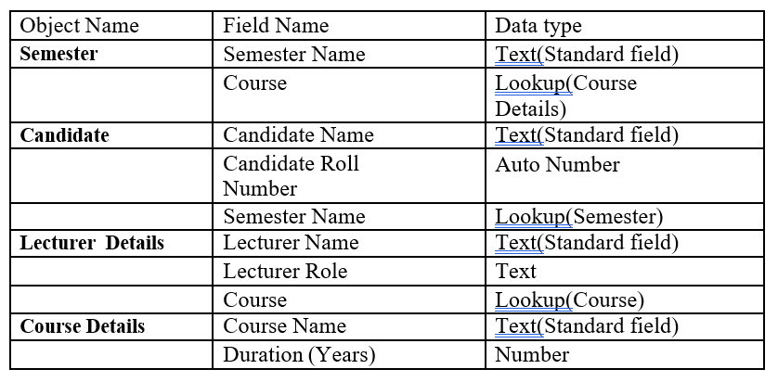

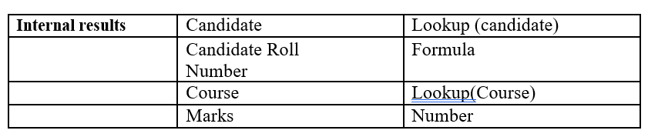

**SEMESTER:**

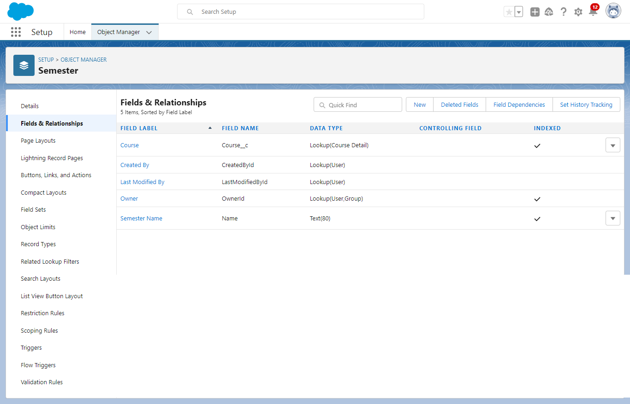

**CANDIDATE :**

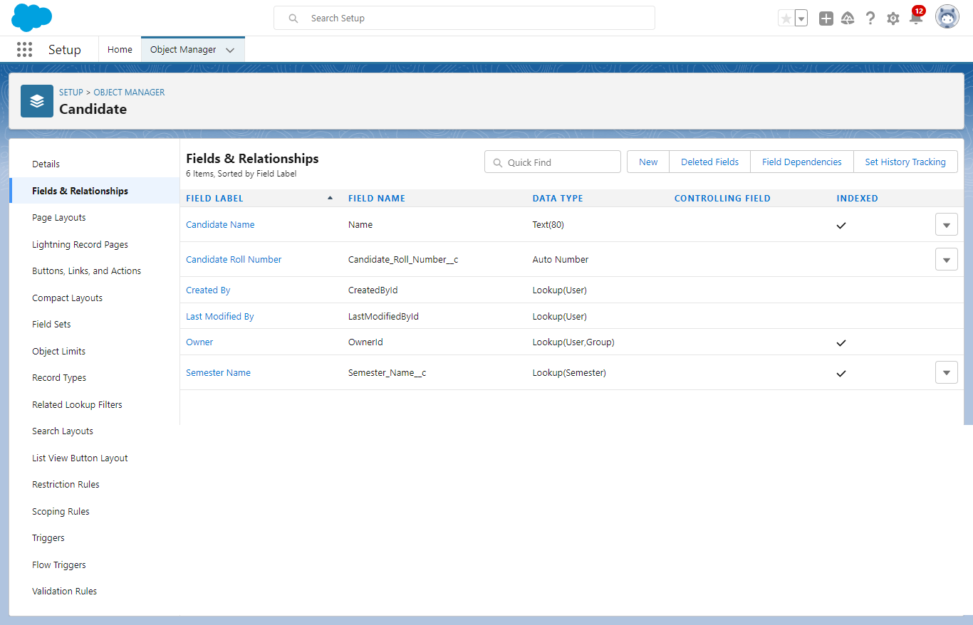

**COURSE DETAILS:** 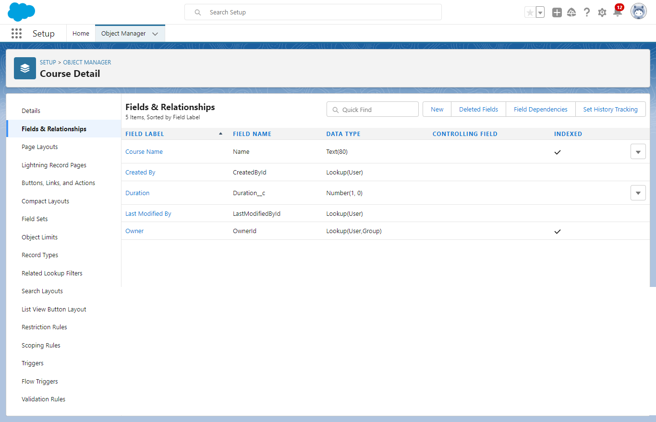

**LECTURER DETAILS:**

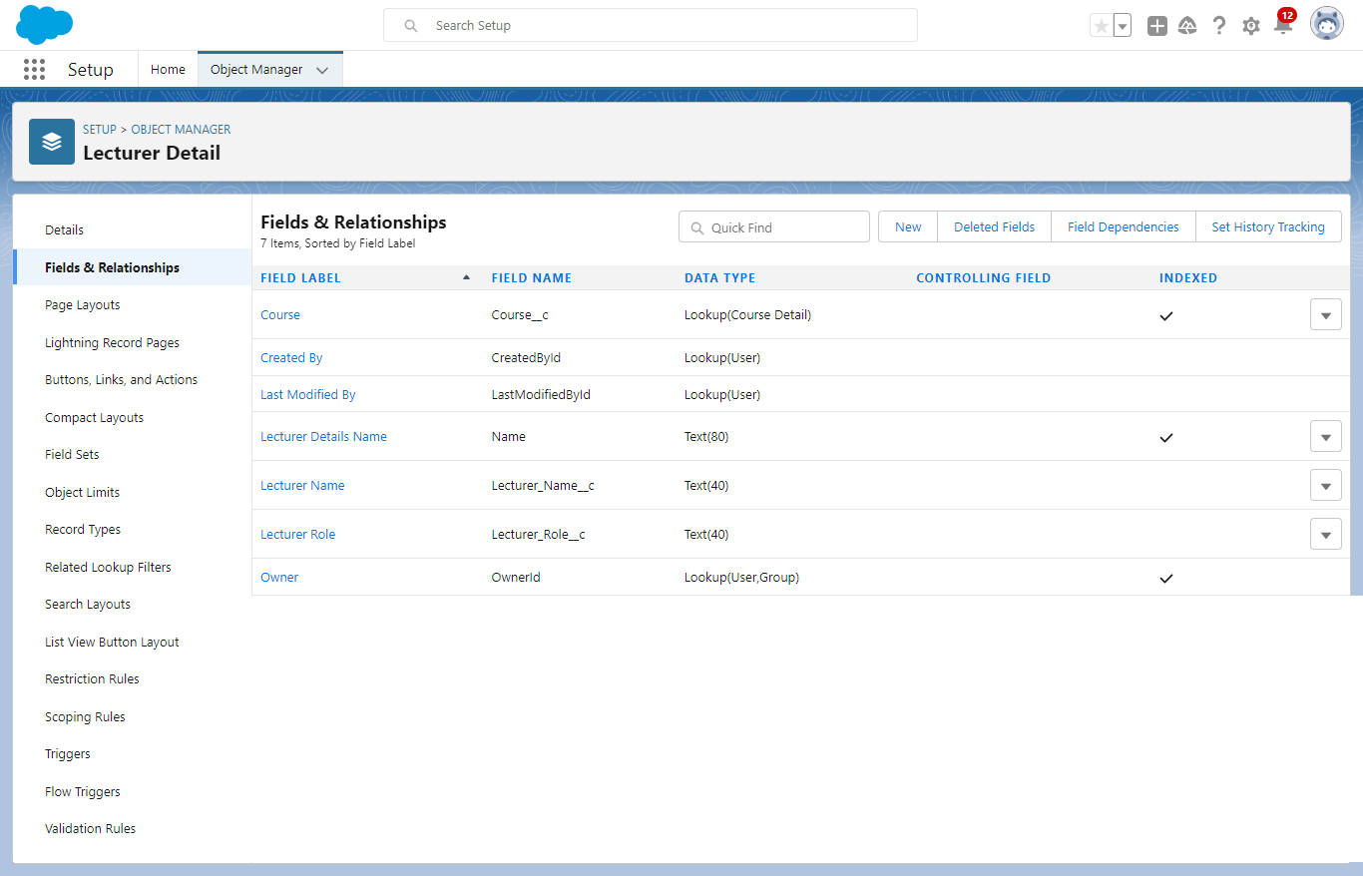

**INTERNAL RESULTS:**

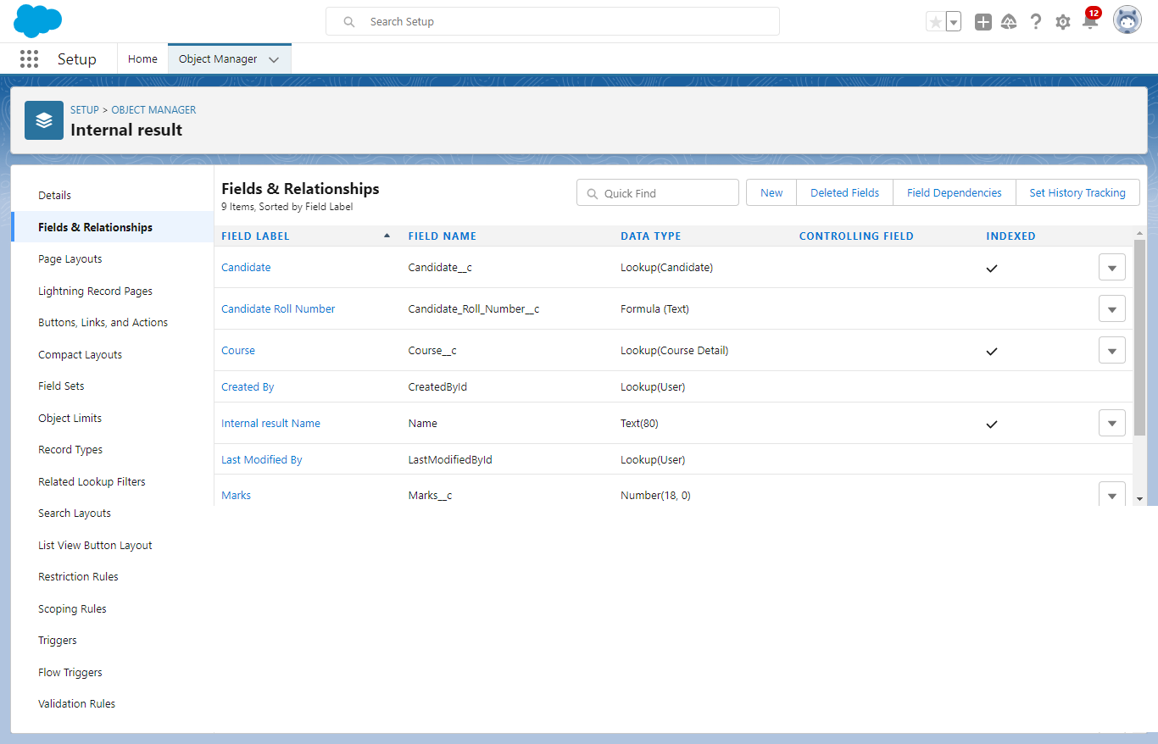

**3.3. Creating Records for Different Objects**

* Semester

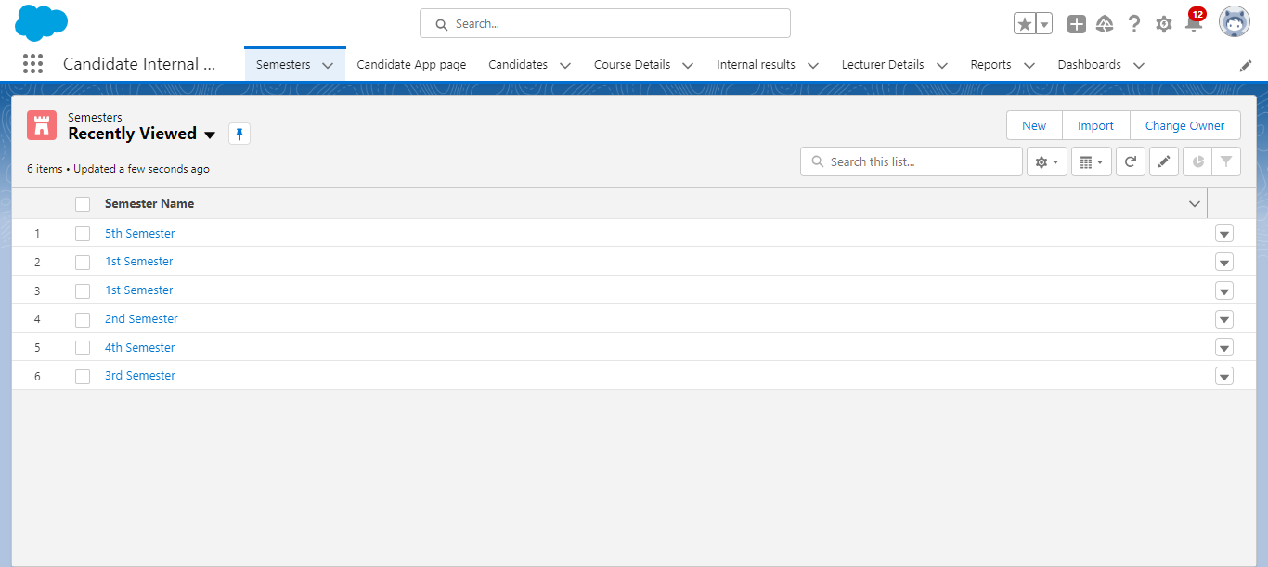

* Candidate

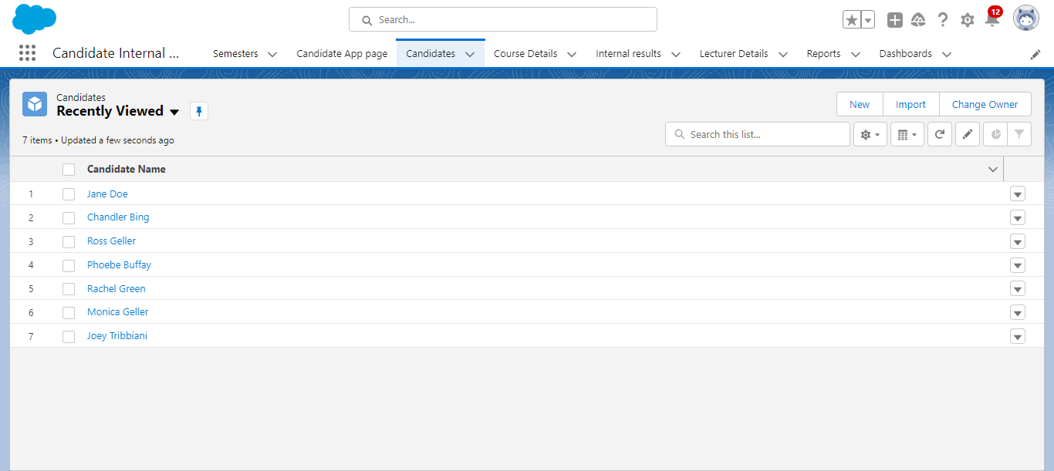

* Course Details

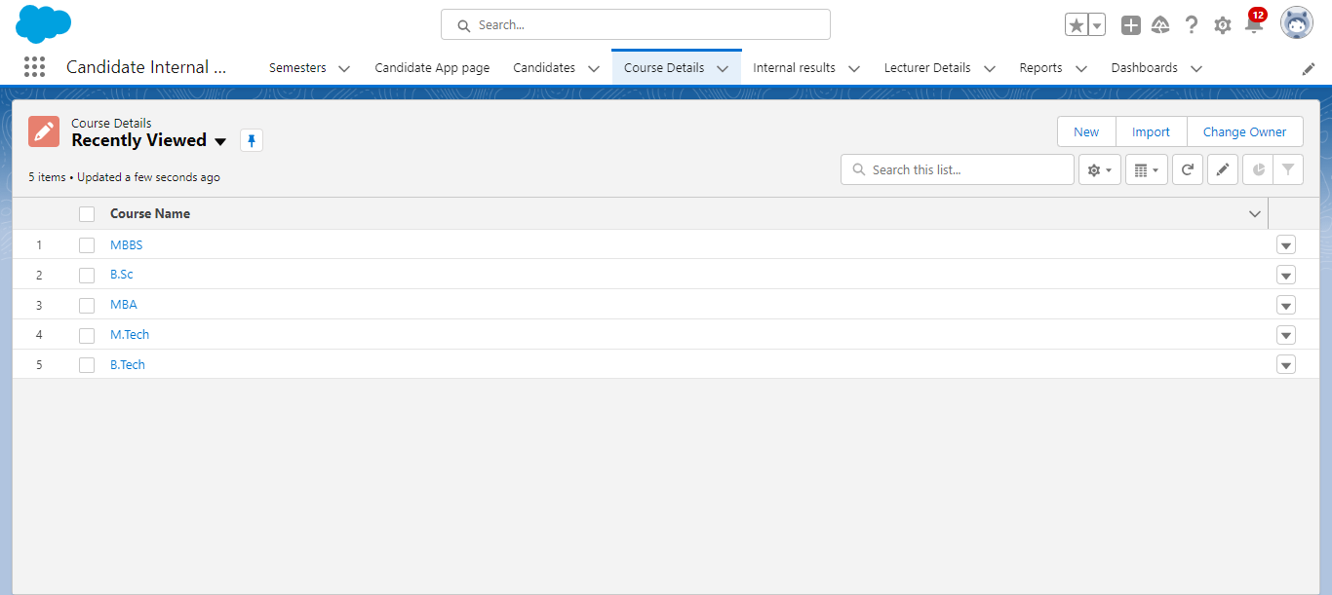

* Lecturer Details

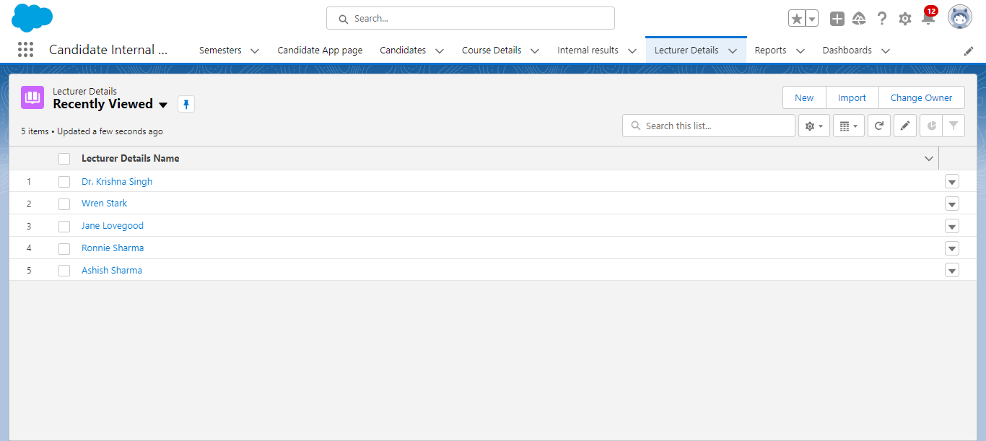

* Internal results.

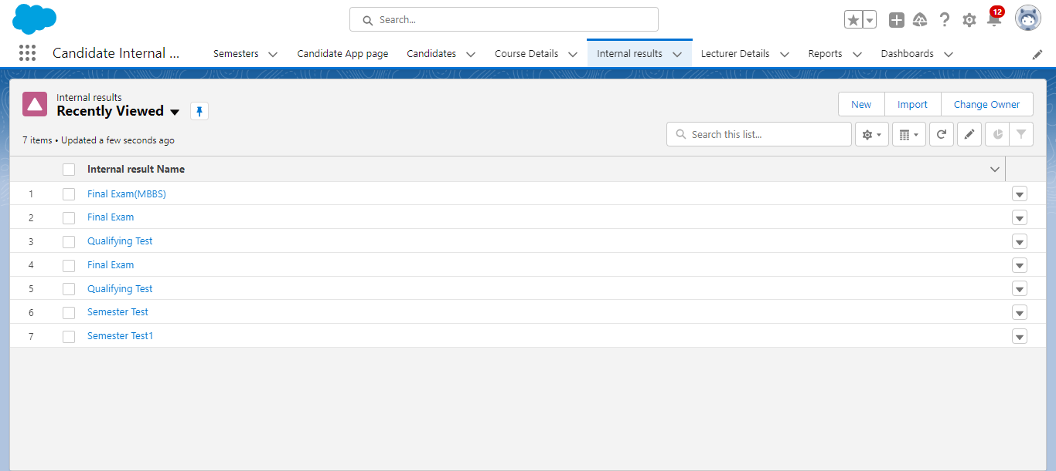

**3.4. Creating Reports**

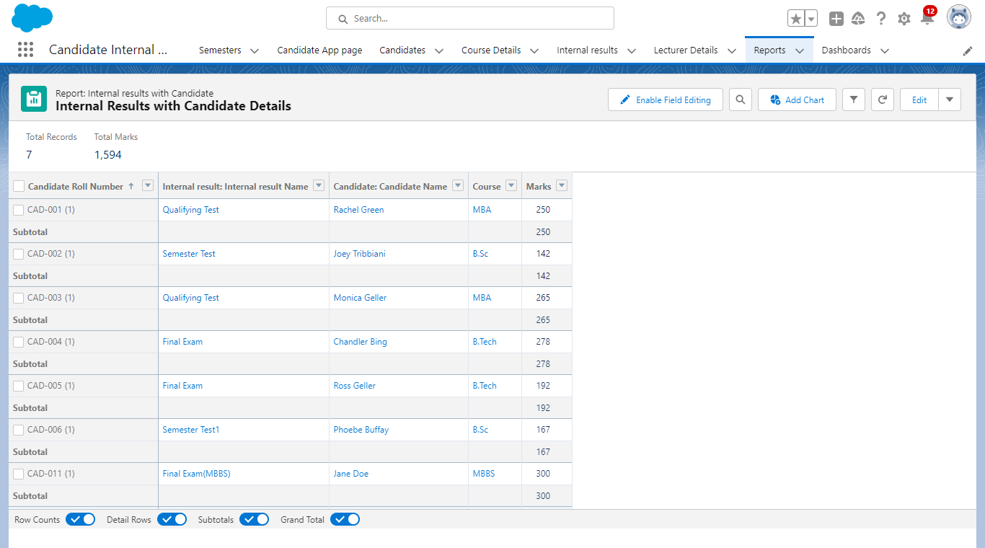

**3.5. Dashboard**

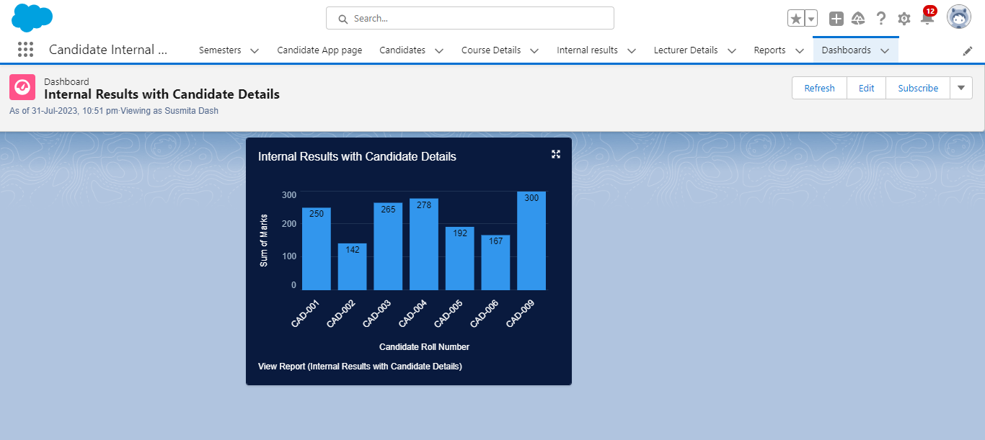

**3.6. Screen Flow**

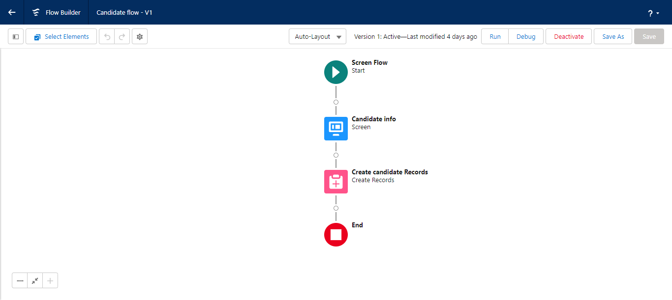

**3.7. Field Update using Triggers**

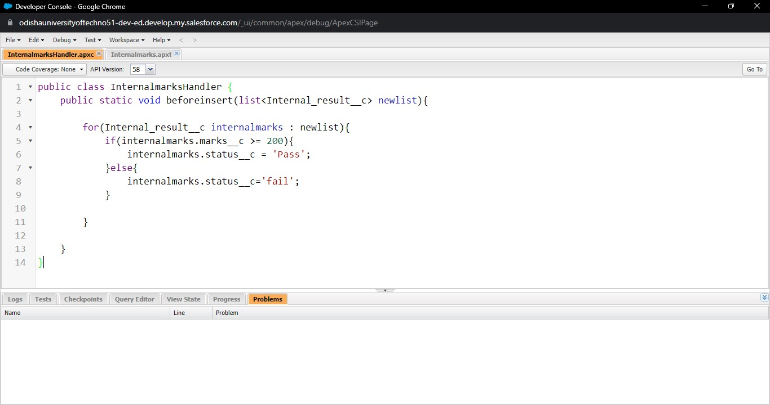

***Fig: the Apex class named as InternalmarksHandler is created***

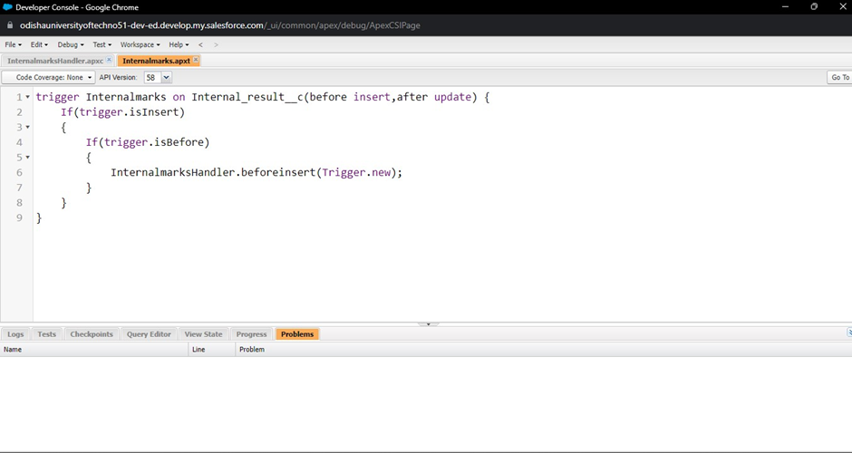

***Fig: the Apex trigger named as Internalmarks is created***

**4. APPLICATIONS:**

1. **Educational Progress:** Simplify result tracking, aiding educators in assessing students and offering targeted help.
2. **Customized Insights:** Identify strengths and weaknesses for personalized guidance, enhancing student learning strategies.
3. **Optimized Management:** Digital records enhance resource allocation, streamlining administrative tasks and student support.
4. **Reliable Evaluation:** Reduce errors, ensuring precise result processing and boosting institutional credibility.
5. **Data Privacy:** Ensure student data security through advanced encryption, building trust among stakeholders.
6. **Comprehensive Reports:** Generate customizable reports for analysis and compliance, enhancing decision-making and transparency.

**5. TRAILHEAD PROFILE PUBLIC URL:**

**Trailhead ID:** <https://www.salesforce.com/trailblazer/sdash220>

**6.PROJECT VIDEO LINK:**

**YouTube Link:** <https://www.youtube.com/watch?v=16uqSiboQr8>

**6. CONCLUSION:**

Integrating Salesforce as a CRM for result tracking brings a transformative solution to educational institutions. This project simplifies result management, strengthens communication, and offers valuable analytics, ultimately cultivating heightened student engagement, well-informed decision-making, and an elevated learning experience. By seamlessly merging technology with education, this initiative addresses multifaceted aspects of student progress, fostering an environment conducive to growth and excellence.